Lion King Jr. COVID-19 Safety Procedures

Important:
Please read and sign Delta Youth Theatre’s Informed Consent form before the start of rehearsals. A student will not be allowed into the rehearsal space until this has been signed and completed by a parent/guardian.

Before arriving, please:
- Use a washroom and wash hands thoroughly.
- Fill your water bottle.
- Wear a mask to rehearsal and prior to entering rehearsal space (we will have some in case students forget).

Arrival and Check-In:
- Please arrive 5-10 minutes before rehearsal so we can start on time.
- Students will be required to wear masks during arrival, check-in and when departing.
- Students will have access to hand sanitizer upon entering the rehearsal space and will have to sanitize hands upon entry (if a student needs to use his/her/their own sanitizer that is fine but we do need to see them apply it).
- Students must complete the Covid-19 checklist regarding his/her/their symptoms (on that particular day) before entering the rehearsal space. The checklist can be found on THE CALLBOARD on our website at deltayouththeatre.com (link: https://docs.google.com/forms/d/e/1FAIpQLSdhVaDOVApZEUde7GRkT2tG2qC3ZKQ8IK1DqPRIjkbcVmd8Ng/viewform).
- Students will be asked to stay distanced when possible and appropriate in the rehearsal hall.

During Class/Rehearsal:
- Instructors and choreographers will wear masks for the duration of the rehearsal.
- Students will be required to wear masks in rehearsals.
- Students who engage in scenes or dances with physical contact will rehearse it with discretion and will be asked to ‘mark it’ whenever possible.

Departure:
- Students must leave rehearsal promptly.
- The rehearsal space will be sanitized appropriately after each rehearsal.
- Students must try not to congregate in groups at the exit or in the parking lot. Please keep distanced when and where possible.

IT IS IMPERATIVE THAT ALL INSTRUCTORS, STAFF AND FAMILIES FOLLOW THESE 4 PRACTICES:

1) STAY HOME IF YOU ARE SICK. The most important measure to prevent the spread of COVID-19 is to stay home if you are sick:

- Stay at home if you have even mild symptoms of illness consistent with cold, influenza, or COVID-19.
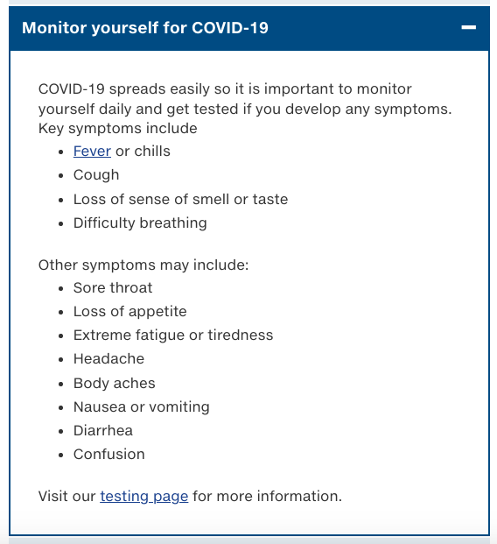
http://www.bccdc.ca/health-info/diseases-conditions/covid-19/if-you-have-covid-19
- If you show any signs of illness, you must remain home until such time as symptoms conclude and/or you can confirm a negative COVID-19 test result. The final decision on whether or not a previously ill individual can return lies with the DYT directors.
- If an instructor or student begins to feel unwell at rehearsal, he/she/they will be asked to go home.
- If someone in your home tests positive for Covid-19, please follow BCCDC guidance on self-isolaton before returning to class/rehearsal.
http://www.bccdc.ca/health-info/diseases-conditions/covid-19/if-you-have-covid-19#self-isolation
- All DYT participants must follow the most current advice posted by the Government of B.C. with respect to travel restrictions, which may necessitate a period of self-isolation and/or testing upon return home. You may not attend rehearsals during this time.

2) WASH YOUR HANDS. Good personal hygiene helps reduce the risk of infection.

- Please wash your hands before arriving at DYT rehearsals.
- All DYT participants must use hand sanitizer upon entry/exit of the rehearsal space, and as instructed throughout rehearsals.
- If you need to cough/sneeze please do so into your elbow.
- Avoid touching your face.

3) KEEP YOUR DISTANCE. Prevent transmission by creating space between people.

- Parents are asked to remain outside the building. Please drop off and pick up your student outside the rehearsal entrance, and avoid congregating with fellow parents in the parking lot while you wait.
- If you use the washroom in the rehearsal area we ask that you wipe down high touch surfaces after use. Please use wipes provided.
- Please wash hands thoroughly. Signage will be posted as a reminder of good hand washing practice.

4) KEEP SURFACES CLEAN AND CLEAN SURFACES OFTEN. Regular disinfection of high touch areas reduces the risk of transmission from contaminated surfaces.

- We will be cleaning high touch areas on a regular basis.
- Instructors will sanitize high touch areas between rehearsals.
- Instructors and students will not be able to use shared equipment unless sanitized.
- We ask students to refrain from cell phone usage once inside the rehearsal area (except in case of emergencies). If cell phones are needed to video/record, hand sanitizer will be mandatory after usage.
- Rehearsal spaces will be aired out between cast 3/4 and 1/2 crossover.

Any parent concerns, questions, and communication will be addressed via email or telephone. We have appointed Tony Barton as the point of contact to address all COVID-19 related communications, compliance, and coordination:
- Email: deltayouththeatre@gmail.com
- Phone: 604-417-7748

Thank you for following these guidelines and working together to keep our DYT family members safe!
This is a living document and will be updated in accordance with the B.C. COVIDd-19 response, including relevant public health orders, BCCDC guidelines and WorkSafe BC protocols.

